GIT Project

Index
1. Problem description 2
2. Solution algorithm 2
1. Installing SSH and GIT 3
2. Setting up SSH connectivity between machines 4
3. Initiating our first repository 4
4. First commit from Terminal 5
5. First commit from GUI 5
3. Solution Diagram 7
4. Solution configuration 7
5. Solution running demonstration 8
1. Repository initialization 9
1.1. Cloning a repository (Client1 [CLI]) 9
1.2. Cloning a repository (Client2 [GUI]) 10
2. Status of the working copy 11
2.1. Status of the working copy (CLI) 11
2.2. Status of the working copy (GUI) 11
3. Adding files to the working copy 12
3.1. Adding files to the working copy (CLI) 12
3.2. Adding files to the working copy (GUI) 12
4. Removing files from the working copy 13
4.1. Removing files from the working copy (CLI) 13
4.2. Removing files from the working copy (GUI) 13
5. Registering changes in the working copy (commit) 14
5.1. Committing from CLI 14
5.2. Committing from GUI 14
6. Creation and use of new branches 15
6.1. Creation and use of a beta branch from CLI 15
6.2. Creation and use of a beta branch from GUI 15
7. Merging two branches 16
7.1. Merging beta to main from CLI 16
7.2. Merging beta to main from GUI 17
8. Adding tags to versions 18
8.1. Adding a tag for beta0.1 from CLI 18
8.2. Adding a tag for beta1.0 from GUI 18
9. Eclipse 19

1. Problem description

We are asked to implement a GIT server for a company with full connectivity between two clients and a server, and full functionality with Eclipse and a GUI of our choice.

2. Solution algorithm

The first logical step is to gather all the possible information about GIT, connectivity between machines (SSH), Eclipse, GUIs for GIT... Once that is done, we can start working.
We are working with three virtual machines (VMs), with one of them being the GIT server and the other two clients.
After setting up the three VMs and ensuring connectivity between them all by setting up a NAT Network and establishing static IP directions to each one of them:
VM | Static IP
Server | 192.168.125.2
Client 1 (CMD) | 192.168.125.3
Client 2 (GUI) | 192.168.125.4

With all of that set up, and after checking connectivity between machines by pinging one another, we can start setting up the basic tools we will be working with.

1. Installing SSH and GIT
The very first step is to check whether the tools we are going to work with come pre-installed or are yet to be installed. We will start with SSH.
The ssh client comes pre-installed most distros, but we will check just in case with:
ssh -V

That only checks the ssh client, which we will need in the client machines, but we will also need to set up a SSH server.
First, we will check whether it is installed or not with the following command:
sudo systemctl status ssh

That should show the following information, along with some more:
● ssh.service - OpenBSD Secure Shell server
Loaded: loaded (/lib/systemd/system/ssh.service; enabled; preset: enabled)
Active: active (running)

If that were not the case, we would proceed to install SSH by means of the following command, and rebooting the machine before checking again:
sudo apt install openssh-server

After ensuring that SSH is up and running, we will proceed to install GIT, as it is very unlikely it is installed by default. We are going to install GIT by using apt:
sudo apt install git

And then check with:
git -v

Which should show something similar to the following (version might be different):
git version 2.39.5

The next step would be to identify ourselves in GIT in each one of the VMs, which requires an e-mail address and a name. For that we are going to execute the following commands:
git config --global user.email "24.javier.pedragosa@insdanielblanxart.cat"
git config --global user.name "JaviPedragosa"

Lastly, we will have to set up our defaultBranch to a different one than the default, which is ‘master’. We will change ours to ‘main’:
git config --global init.defaultBranch main

2. Setting up SSH connectivity between machines
In both clients, we will generate SSH keys and copy them to the server.
To generate the key, we will run the following command:
ssh-keygen -t rsa -b 4096
And then check that it has been successfully created:
ls ~/.ssh/
Lastly, we will copy the key to the server with:
ssh-copy-id super@192.168.125.2
which should ask us for the password of the ‘super’ user on the server.

After that, we can verify the connection by using the following command, if we are not asked for a password that means we have correctly set it up:
ssh super@192.168.125.2

3. Initiating our first repository
With GIT and SSH installed in the three VMs, we will proceed to set up the server first, which starts by creating a new user we will call ‘git’:
sudo adduser git
After that we will switch to that user and create and initiate our first bare repository:
cd /home/super/git
mkdir test
cd test
git init --bare

Lastly, we will clone it, create any kind of file and commit it from the server in order for us to have a non-empty repository to work.
git clone ~/git/test ~/test
cd ~/test
echo "First commit from server" > testServer.txt
git add .
git commit -m "First commit from Server"
git push origin main

4. First commit from Terminal
With the SSH connection set up and GIT repository initiated, we should be able to clone and commit from the clients.
To clone it, we are going to execute the following command:
git clone super@192.168.125.2:/home/super/git/test ~/test

And then we will create a change to try and commit from the CMD client:
cd ~/test
echo "First commit from Client 1" > testClient1.txt
git add .
git commit -m "First commit from Client 1"
git push origin main

If no errors are shown, we have successfully set it up and verified that the GIT flow via Terminal is working correctly.

5. First commit from GUI
In the second client, the one meant for using a GUI, we are going to install GIT-GUI, which is a simple and lightweight GUI for GIT. For that, we are going to execute the following:
sudo apt install git-gui
Then, we will open GIT-GUI and clone the repository by following the instructions and using the following URL: ‘super@192.168.125.2:/home/super/git/test’ with de defined path: ‘/home/super/test’.
After that, we will generate a similar change as we did from the first client, by doing this:
cd ~/test
echo "First commit from Client 2" > testClient2.txt

Then, the GUI will show the new file ‘test2.txt’ in the Unstaged Changes tab. We can write a Commit Message and then click on Stage Changed > Commit > Push to successfully commit using GUI.

3. Solution Diagram
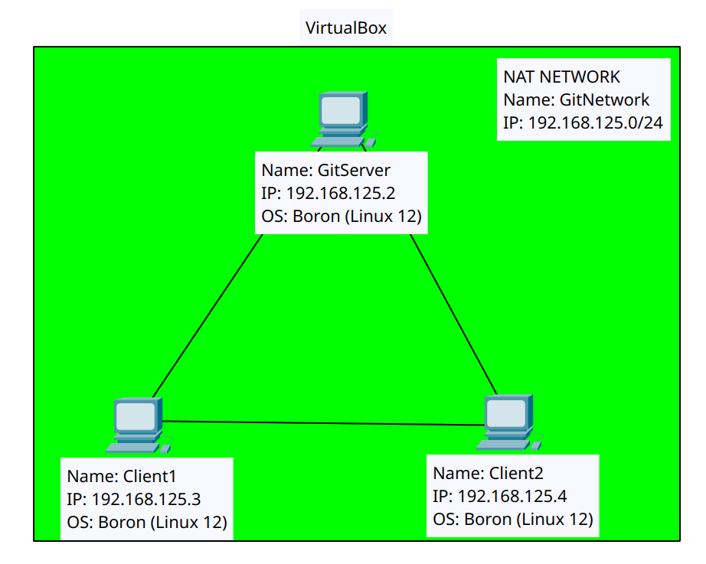

4. Solution configuration

The configuration needed for this project was simply for the networking, as every tool or program we installed and/or used made all the needed configuration for us and the only thing I had to tinker with was for the machines to be able to connect to one another.
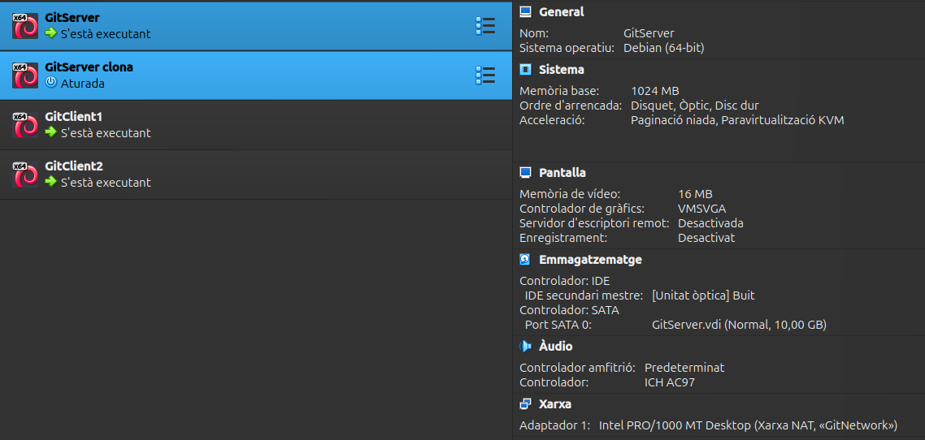
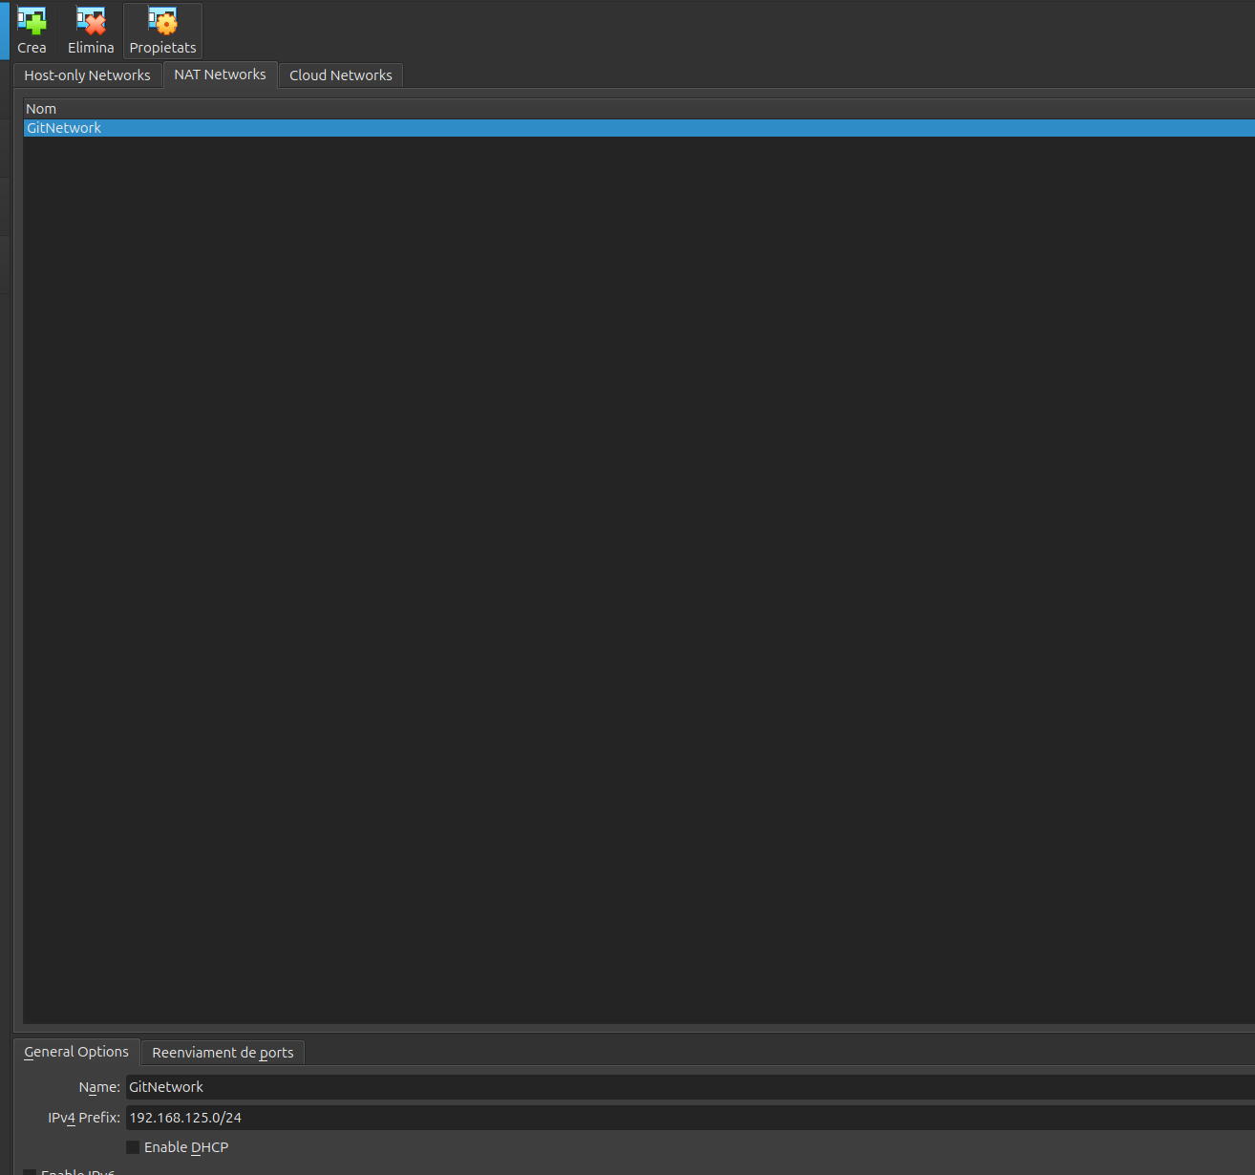Figure 1: NAT Network in VirtualBox

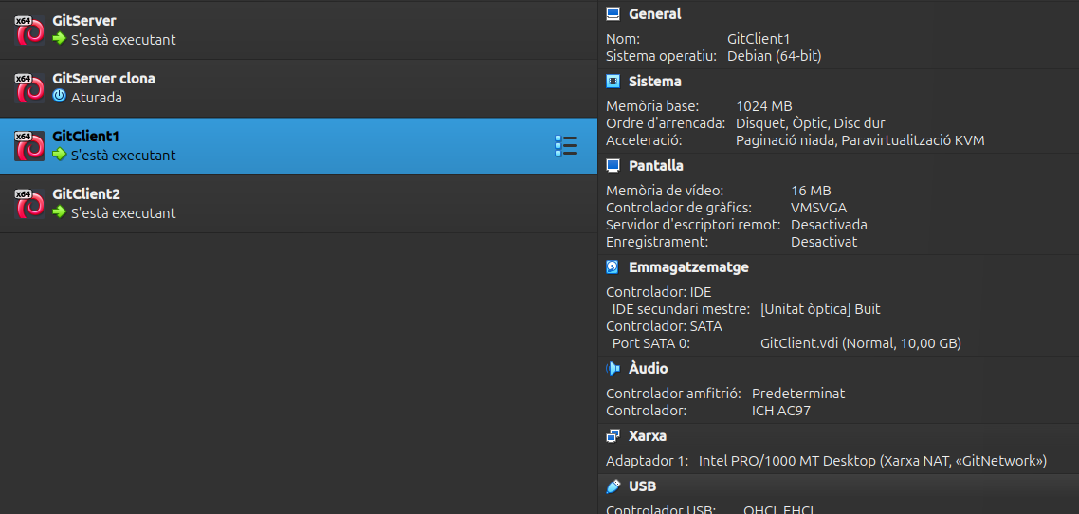

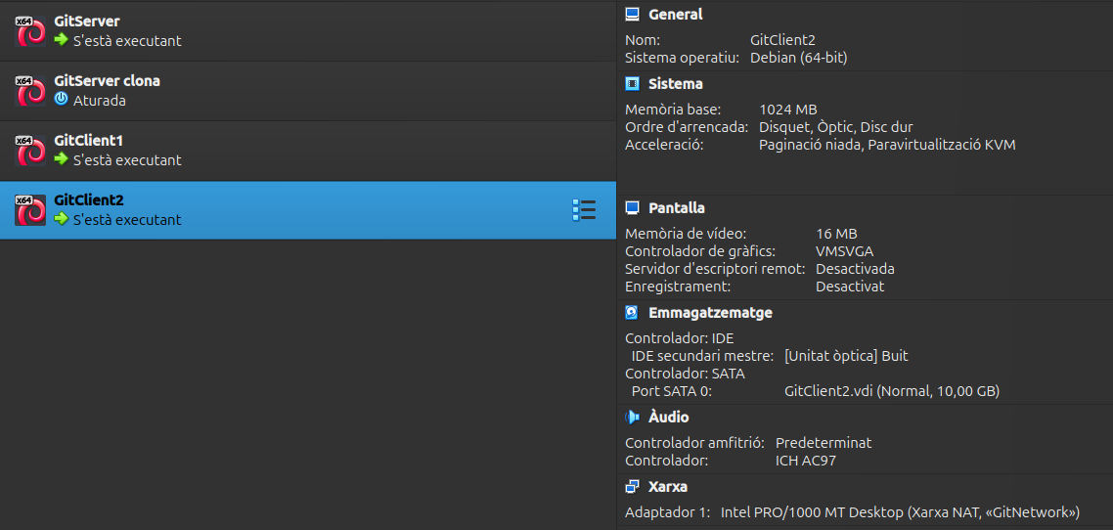Figure 2: Settings on each one of the 3 VMs

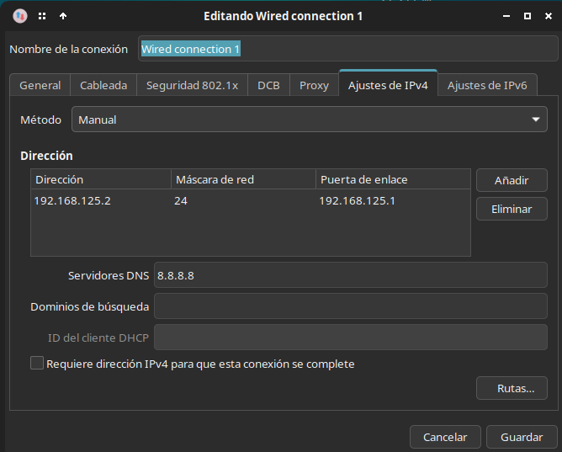Figure 3: Boron settings where static IP was set (In this case, in the server)

5. Solution running demonstration

In this section, we will run through the required operations one by one both from Client1 (CLI) and Client2 (GUI).

1. Repository initialization
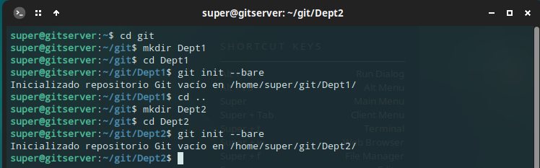Figure 4: Process of initiating two repositories from CLI in the Server VM

1.1. Cloning a repository (Client1 [CLI])
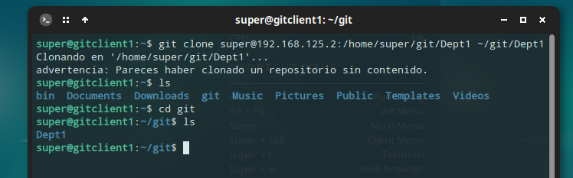Figure 5: Process and demonstration of a repository being cloned in CLI

1.2. Cloning a repository (Client2 [GUI])
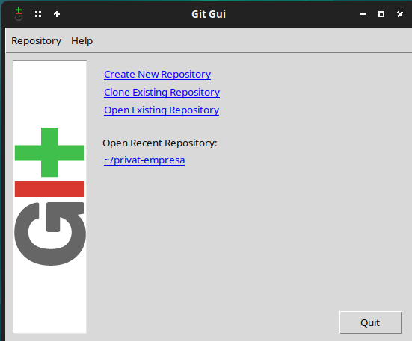Figure 6: Git Gui's main menu, where the option we will select for cloning a repository is highlighted in a red box
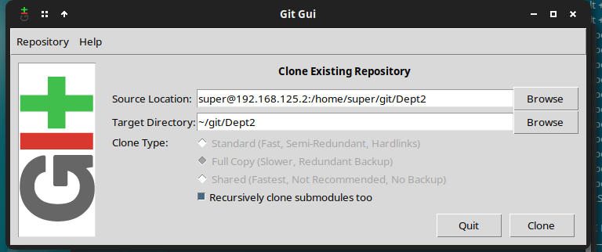Figure 7: Git Gui's Clone Existing Repo. window where we set the source and the target before clicking on Clone

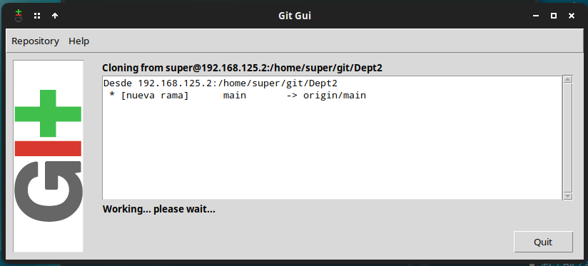Figure 8: Git Gui working on cloning the repository

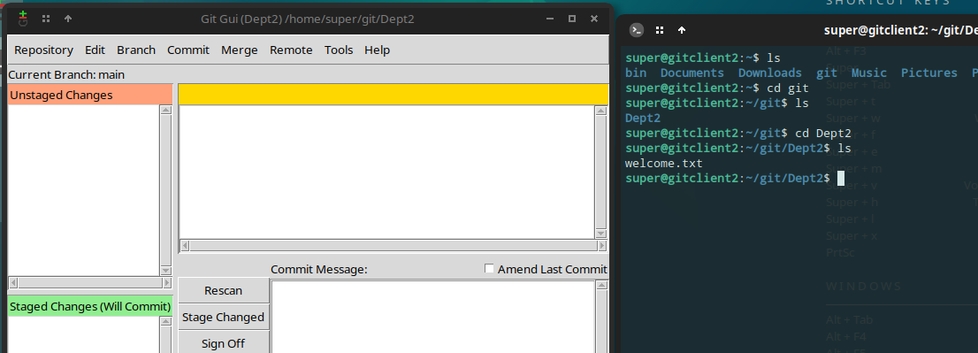Figure 9: Demonstration of the repository already cloned

2. Status of the working copy

2.1. Status of the working copy (CLI)
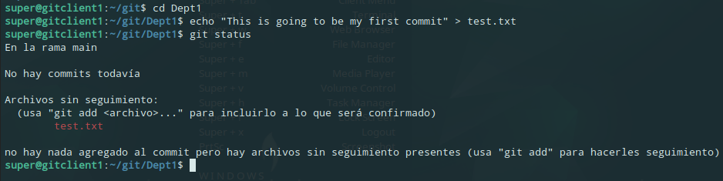Figure 10: Process of creating changes and showing the current status of the Working Copy in CLI

2.2. Status of the working copy (GUI)
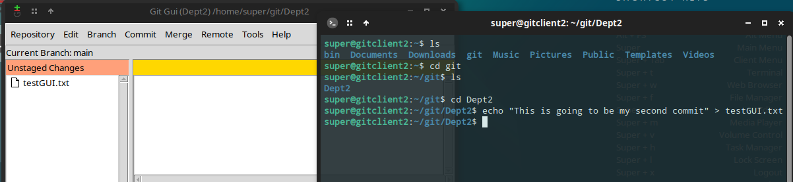Figure 11: On the right side, CLI showing how I have made a change to the files in the repository. On the left side, Git Gui showing the change as an Unstaged Change after clicking the 'Rescan' button

3. Adding files to the working copy

3.1. Adding files to the working copy (CLI)
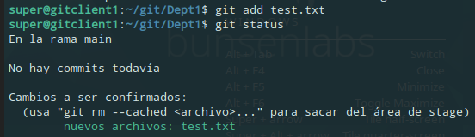Figure 12: The command ‘git add’ being used to stage changes and the status to demonstrate

3.2. Adding files to the working copy (GUI)
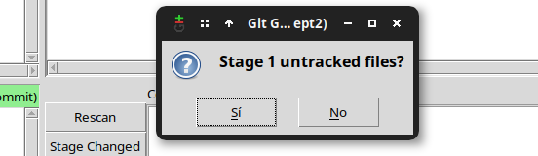Figure 13: The Stage Changed button highlighted in red is the one that lets us stage changes, after confirmation by clicking 'yes'
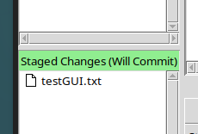Figure 14: Staged changes ready to be commited will be shown here

4. Removing files from the working copy

4.1. Removing files from the working copy (CLI)
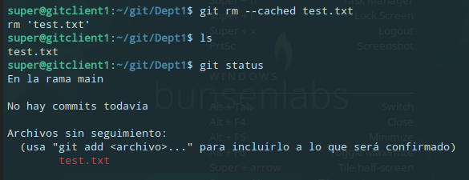Figure 15: File test.txt being removed from the staged changes, without deleting the file, and demonstration of the status not showing it as a staged change anymore

4.2. Removing files from the working copy (GUI)
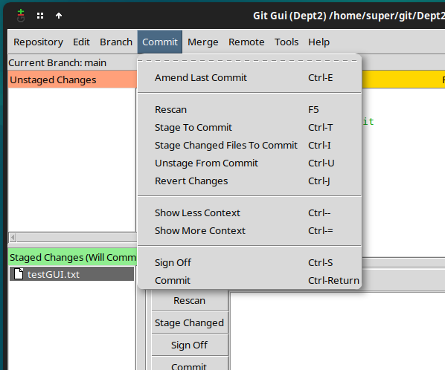Figure 16: Commit menu where the option that unstages changes is highlighted in red.
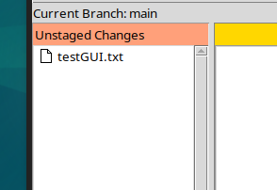Figure 17: Change showing up in the unstaged changes tab after clicking ‘Unstage From Commit’

5. Registering changes in the working copy (commit)

5.1. Committing from CLI
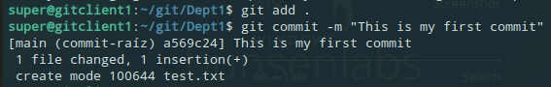Figure 18: All changes being staged and then commiting with a comment.

5.2. Committing from GUI
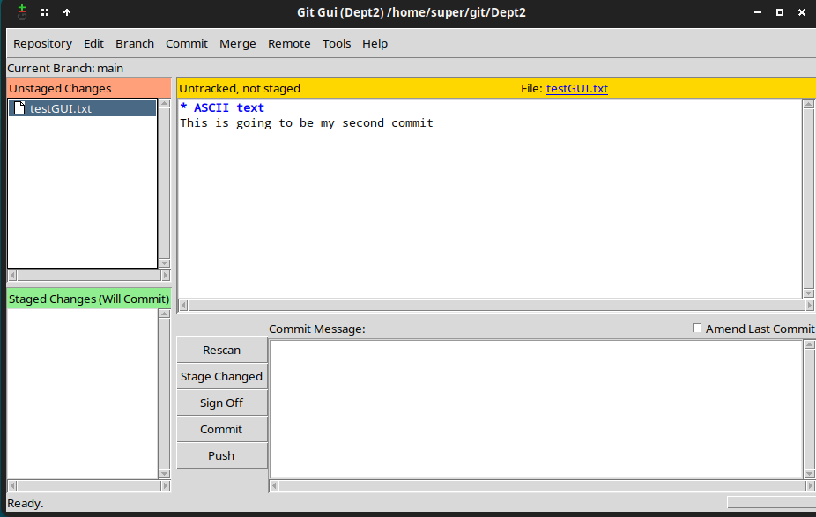Figure 19: Unstaged Changes will be staged upon clicking the highlighted button
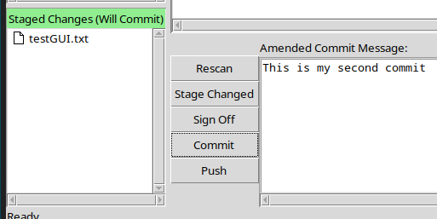Figure 20: After defining a Commit Message, clicking Commit will register the changes in the working copy

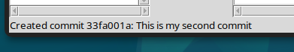Figure 21: Message telling us our commit was created

6. Creation and use of new branches

6.1. Creation and use of a beta branch from CLI
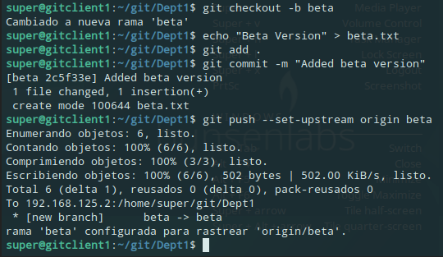Figure 22: Creation of beta branch and a new file for that branch. Change is commited and pushed to the beta branch.

6.2. Creation and use of a beta branch from GUI
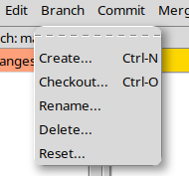Figure 24: Branch menu on Git Gui, where the Create button will open a window that will allow us to define and create a new branch
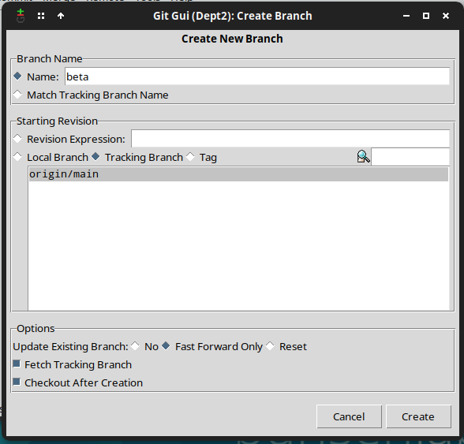Figure 23: The create branch window were we have defined our branch

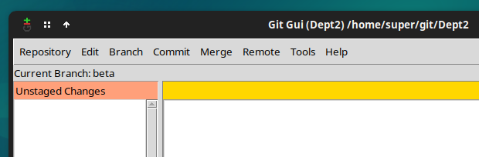Figure 25: Git Gui telling us we are currently working on the beta branch

7. Merging two branches

7.1. Merging beta to main from CLI
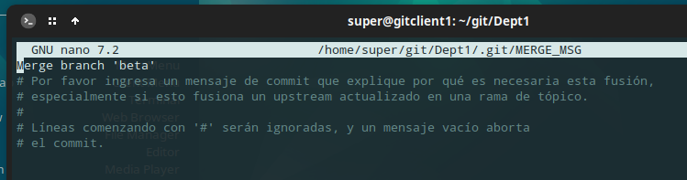Figure 27: Automatically nano opens up a file to add a comment about why we are merging the two branches
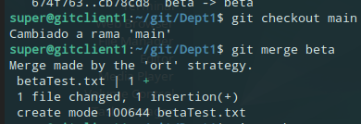Figure 26: Swapping to the main branch and then calling the merge function

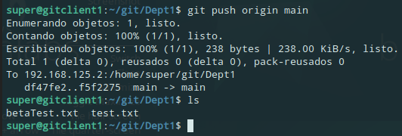Figure 28: Merge being pushed and files from both branches showing up together

7.2. Merging beta to main from GUI
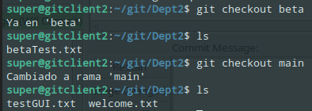Figure 29: Two branches with different files

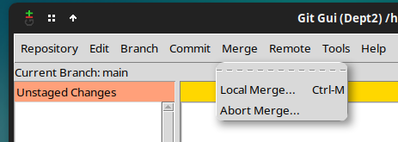Figure 30: While in main, we open up the Merge menu and click on 'Local Merge...'

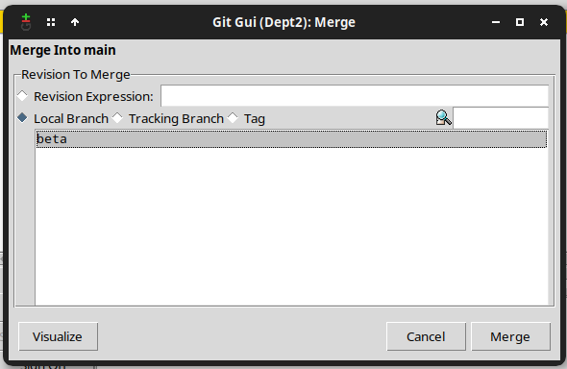Figure 31: We select the branch we want to merge into main and click on 'Merge'
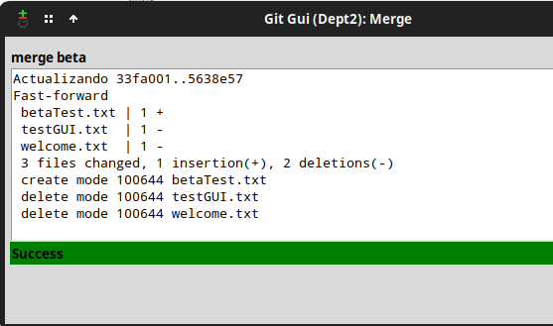Figure 32: Message telling us we have successfully merged beta into main

8. Adding tags to versions

8.1. Adding a tag for beta0.1 from CLI
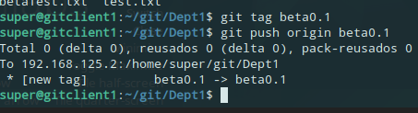Figure 33: Tag being created and pushed

8.2. Adding a tag for beta1.0 from GUI
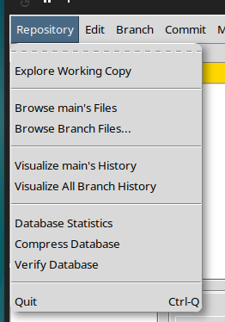Figure 34: In the repository menu, we will click on 'Visualize main's History'
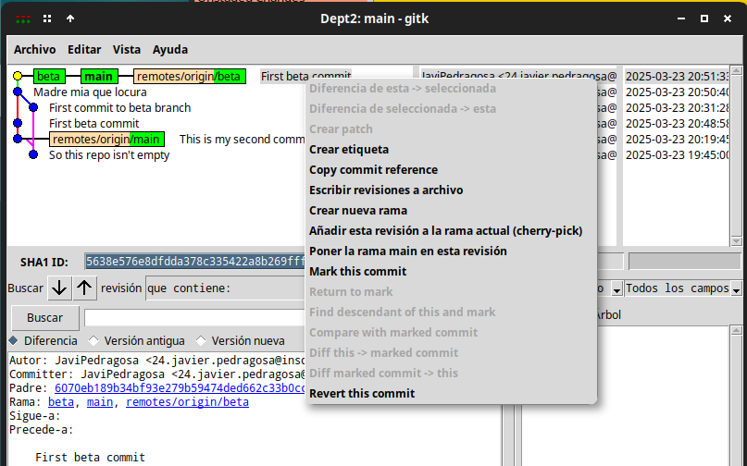Figure 35: We will right click the commit we want to add a tag to and click on 'Create tag'

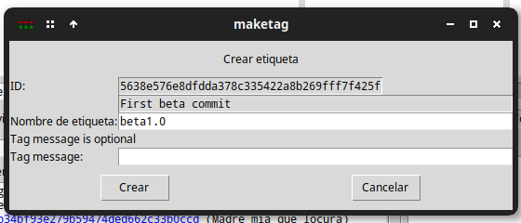Figure 36: We set the name we want to our tag, and click on 'Create'

9. Eclipse
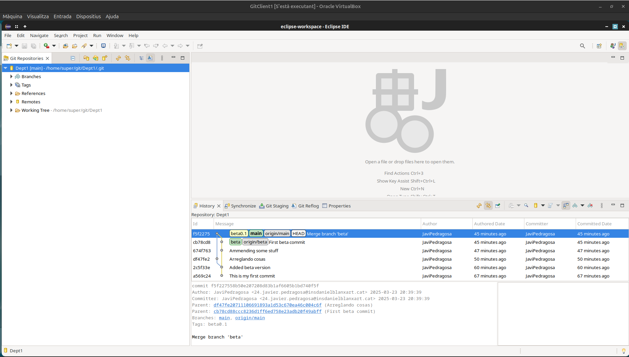Figure 37: Eclipse showing the Dept1 Repository with its versions history
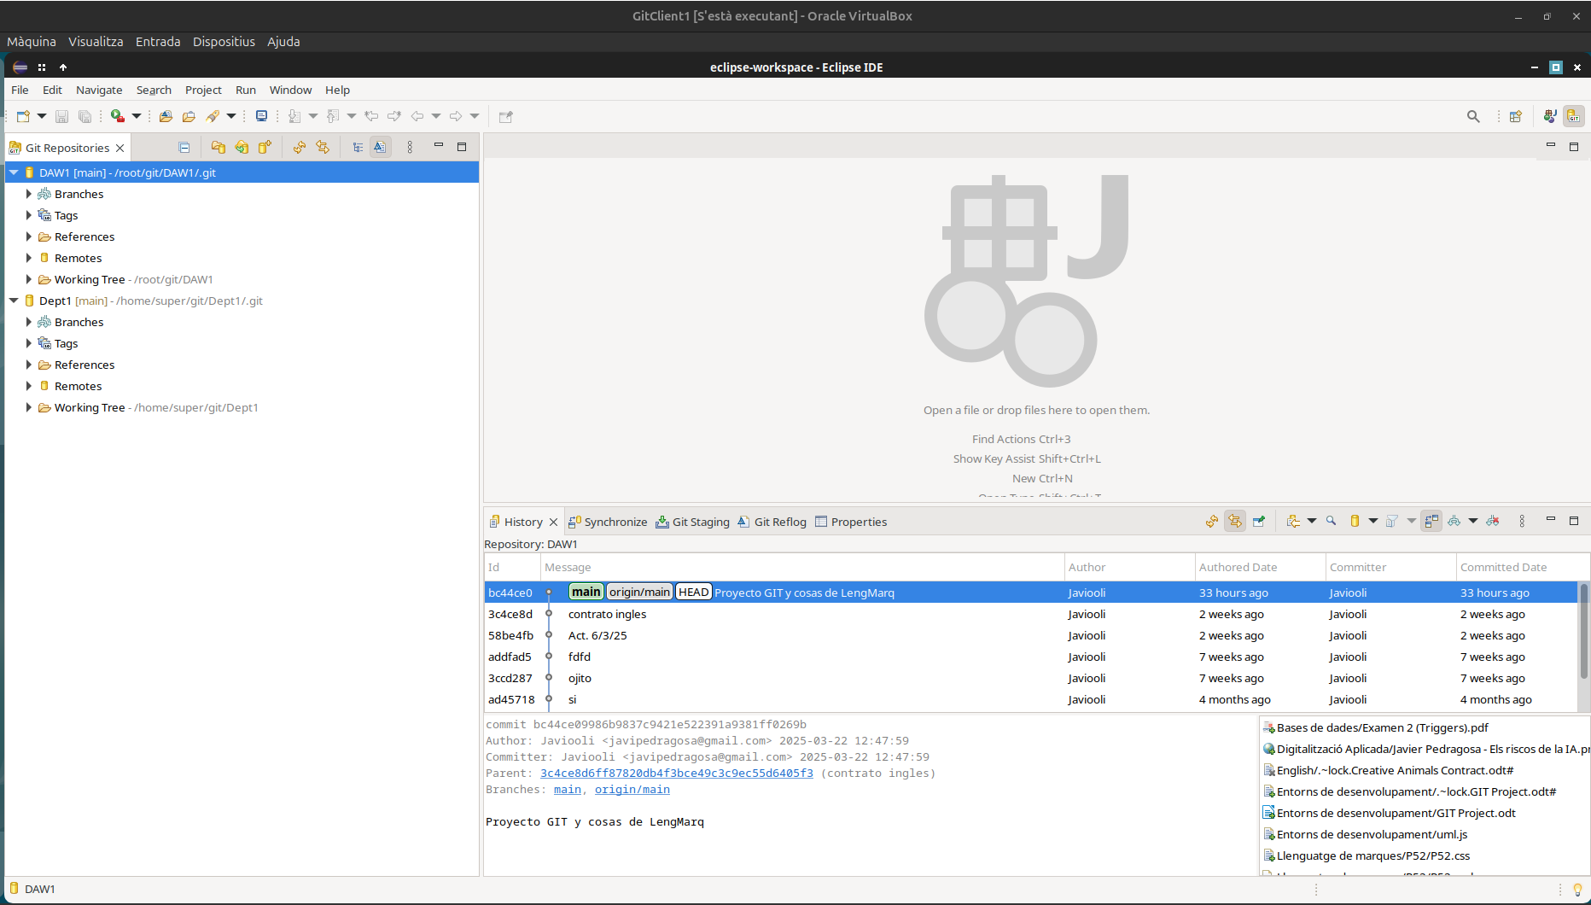Figure 38: Eclipse showing my GitHub repository which can be found on https://www.github.com/Javiooli/DAW1

